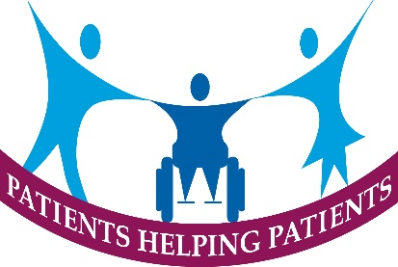
Notes of Patient Participation meeting – 6th February 2024
Seventeen members attended with one apology.
Practice Report
The Breast Screening Service will be inviting female patients registered at the practice aged 50 -70 years of age to be screened at the mobile unit at Newton House, Cheadle Road between February and April 2024.
The Practice Newsletter for winter has been published and copies available on website, Facebook and in Reception.
Patients failing to attend appointments (DNA’s) were discussed at length and possible interventions to reduce numbers were discussed. To be further explored at next meeting.
Still recruiting a replacement Receptionist and interviews pending.
New automated back door to be fitted in February.
Update on Questions to ICB
Still not received replies to all questions raised at November PPG meeting but hoped that more informative answers will be received at March PPG meeting when ICB Director present.
Display /Communication Sub groups
New display regarding Breast Screening developed and put up in Waiting Room, Regular contributions on Moorlands, Churnet and Leek Radio to distribute local health news now operational.
Patient Survey
Agreed to plan to carry out in Practice survey early summer, new questionnaire to be developed to meet needs identified by Practice.
Supporting Patient Online Access
Preliminary work carried out to develop a suitable paper guide to act as reminder for patients who decide to use Patient Access. This will be reviewed alongside NHS App developments
Patient Locality Group
New Chair appointed with existing Deputy and Secretary continuing for further year. A number of Practices reported that they had recruited a number of new members.

